ST.LUKE BAANABAKINTU PRIMARY SCHOOL

Name: -----------------------------------

School: ---------------------------------

District: -------------------------------

**Fill in the correct words. on , under , in , over**

____________ ________

**__________** **_______**

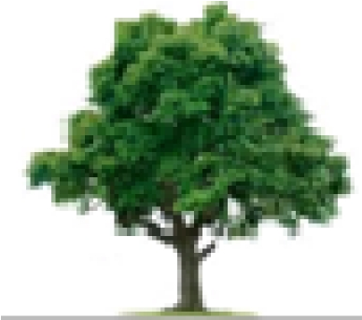

**Ring the bigger number.**

|  |  |  |
| --- | --- | --- |
| 6 | and | 16 |
| 5 | and | 0 |
| 12 | and | 21 |
| 3 | and | 1 |

**Form words from the wheel.**

____________

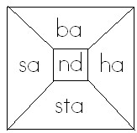____________

____________

____________

**Match these people to their names.**

guard

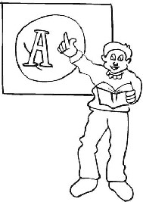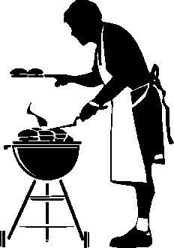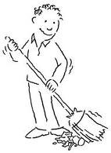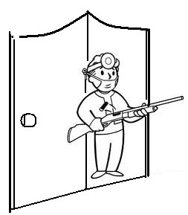

cleaner

teacher

cook

.

**Read and draw.**

on over in near

**Reading Read and underline words of sound “ay”.**

The eggs are on the tray.

I can say the given letter sound.

Go to the sick bay now.

My birthday is in the month of May.

# Aptitude

**Fill in the missing letters.**

te ___ cher g ___ ard ___ urse head ___ eacher c __ __ k

**Write correct sentences from the table.**

|  |  |  |
| --- | --- | --- |
| The boys She  It  We He | want  wants | to play. to drink juice. to go to school.  to skip the rope.  to read a book. |

________________________________________

_________________________________________

_________________________________________ _________________________________________ Numbers Write its number name.

4 _____________

8 _____________

7 _____________

19 _____________

**Complete these sentences correctly.**

This is a yellow 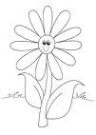 _____________

The Uganda _____________ has

three colours.

Tea is in the ____________

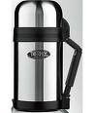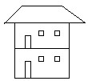

That is a _____________

# Aptitude

**Read and draw.**

dancing sweeping cooking

**Draw a children playing with a ball.**

**English Write in plurals.**

**One Many**

Ball balls

Girl ____________

Tomato ____________

Cake ____________

Knife ____________

# Numbers

**Read and add**

Three plus five equals

_______________________

Four and two gives

_________________________ Six plus one equals

_________________________

Zero and five gives

________________________

**Write sentences using the given words**

Broom

_________________________________________

Brown

______________________________________

Bread

_________________________________________ Brush _________________________________________

# Aptitude

**Change the words in capital letters** sweep ____________ play ____________ draw ____________ clean ____________ write ____________ _______________________ I am ______________ years old.

I am in __________________ class. **English**

**Fill in “is” or “are” to complete the sentences.** Here _____________ is a big tree. The girls ____________playing with a ball.

We ______________going to school.

Daddy ______________driving a new car.

They ____________ eating bananas.

# Numbers

**Solve**:

Akim has three mangoes. Peter has five mangoes. They have ______________ mangoes altogether.

_______ + ______ = ______

**Underline words with sound “sw”**

sweet stick sick see sweep tree

box bag swim

swing swamp sit

**Aptitude Match these animals to their young ones.**

cow fry

goat calf

bird nestling

fish calf pig piglet ______________________ I am ______________ years old.

I am in __________________ class.

# English

**Add “ing” on the given words.**

|  |  |
| --- | --- |
| cry |  |
| make |  |
| draw |  |
| sweep |  |
| mop |  |

**Numbers** John has six eggs.

Brian has four eggs How many eggs do they have altogether?

They have ______________ eggs.

_______ + _____ = ______

**Fill in letter sound “ck” in the given words.**

ti _______ so _______ clo _______ si _______ sti _______ pa _______

# Aptitude

**Read and draw.**

dog

pig

rabbit

cow

hen

My name is _______________________ I am ______________ years old.

I am in __________________ class.

**English Name these animals.**

|  |  |  |  |
| --- | --- | --- | --- |
|  |  |  |  |
|  |  |  |  |

**Numbers Find the missing number.**

+4 = 7 3 + = 6

+ 0 = 9 5+ = 10

**Use which , when , when , who , what in the given sentences.**

_______________ is your name?

_______________ is your birthday?

_____________ is your best friend?

______________school are you now?

# Aptitude

**Colour using the given colours.**

brown shoes. a green leaf

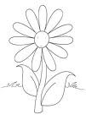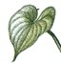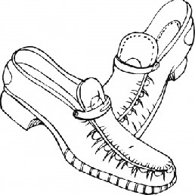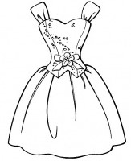

a red dress. a yellow flower.